

IBM AIX Infrastructure Design Document
Version : Draft v 0.3
September 2013

Table of Contents
1 Introduction 2
1.1 Background 2
1.2 Purpose of This Document 2
1.3 Detailed Business/Application Requirements 2
1.4 Risk, Assumptions, Issues and Dependencies (RAID) 2
2 Solution Overview 3
2.1 Layered Architecture of the Hosting Solution 3
3 Hosting Platform Logical Design 4
4 Detailed Infrastructure Hosting Design 4
4.1 Midrange Hosting Design (AIX) 4
4.1.1 Power Server Configuration Details 5
4.2 Detailed Midrange Configuration Design 5
4.2.1 AIX LPAR profile configuration 6
4.2.2 Storage configuration for LPARs 9
4.2.3 Host Based Mirroring on AIX 9
4.2.4 Network Configuration for LPAR 11
4.2.5 VIO LPAR Configuration 11
4.2.6 HMC Configuration 13
4.2.7 NIM Server Configuration 14
4.2.8 AIX-LDAP Server Configuration 16
4.2.9 Clustering configuration using HACMP 18
4.2.10 NTP Service 19
4.2.11 Antivirus and Patch and Update Management 19
4.2.12 Midrange Scalability 20
4.3 Monitoring 20

Introduction

Background
Automating the LPAR deployment in IaaS cloud infrastructure

Purpose of This Document

Detailed Business/Application Requirements

Risk, Assumptions, Issues and Dependencies (RAID)
Following are the risks foreseen with possible mitigation option where available, assumptions made to derive the solution, known issues and dependencies on other areas.

RAID | Description | Probability  (Only Risks) | Comments
Risk | Any major changes to the system requirements of products/application which will be used within this project will affect the proposed solution. | Low | N/A
Risk | Automation of Storage LUN provisioning method (NPIV or Shared Storage Pool) will be finalized after testing . | Medium | Currently the nodes can be part of one shared storage pool, this, limits us in providing one tier type of storage
Risk
Assumptions | BMC Blade Logic can automatically create AIX profile and can push OS images | N/A | N/A
Assumptions | Active memory sharing will be deployed , if the peek workloads are over lapping |  | Server performance peeks on different times of the day
Issues | Active Memory sharing cannot be implemented with Shared Storage Pool disks | N/A | N/A
Issues |  | N/A
Issues |  | N/A
Dependency |  | N/A | N/A
Dependency |  | N/A | N/A
Dependency |  | N/A | N/A
Dependency |  | N/A | N/A

Solution Overview

Layered Architecture of the Hosting Solution
The following diagram illustrates layered architecture (logical view) of the Production hosting infrastructure.

Hosting Platform Logical Design
This section explains the logical hosting solution for each of the proposed solution components divided based on the business or application services provided.
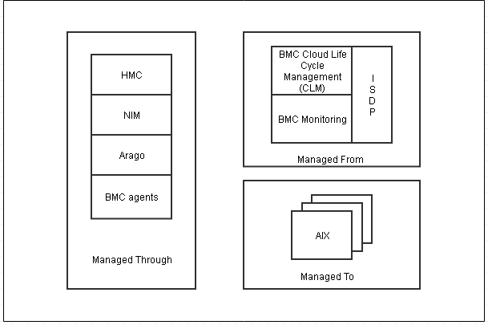
Component | Description
Managed Through
HMC | Hardware Management Console (HMC) to Manage the IBM Power Logical Partitions
NIM | Network Installation Management (NIM) facilitates the installation and management of AIX file sets on machines over the network.
Arago | Arago auto pilot for Operation automation
BMC agents | Connect with the BMC CLM
Managed from
BMC CLM | BMC Cloud life cycle management suite (BBSA, BBNA etc )are included to manage the cloud infrastructure
BMC Monitoring | BMC ProactiveNet Performance Management (BPPM) to Monitor the infrastructure
Managed to
AIX | The base operating system built into the installation image.

Detailed Infrastructure Hosting Design
This section describes the deployment architecture, detailed clustering and load balancing solution for AIX LPARs service and its components.

Midrange Hosting Design (AIX)
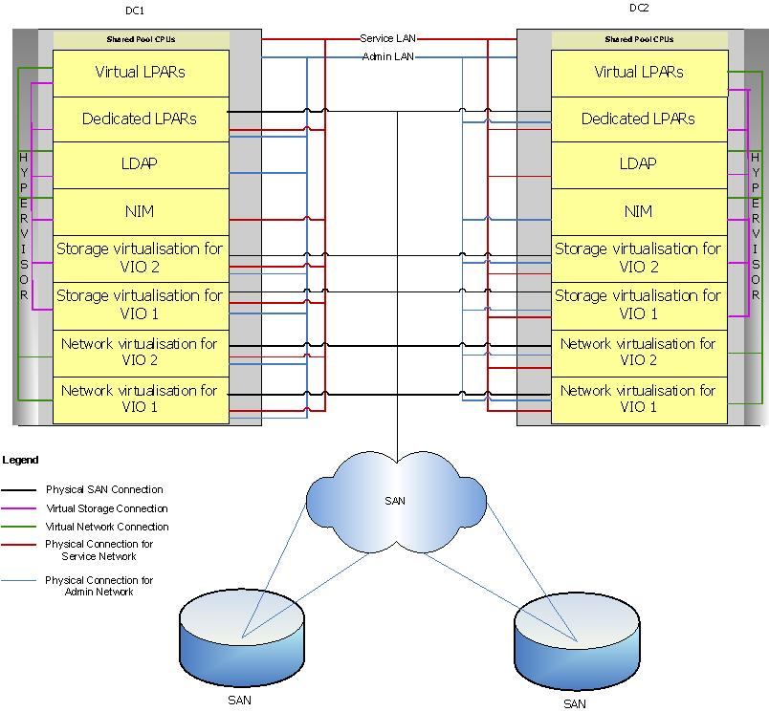

Detailed Midrange Configuration Design
Following sub-sections describe the detailed configuration for hosting components running on IBM AIX LPARs.

AIX LPAR profile configuration
This section details the general AIX configurations for all the LPARs
- All LPARs will be configured to use shared pool CPUs with “uncapped” setting

Standard File Systems
Filesystem | Size
/ | 1 GB
/usr | 4 GB
/var | 1 GB
/tmp | 2 GB
/home | 2 GB
/home/users | 2 GB
/opt | 2 GB

Weighting
Server Type | Weightage
VIO Server | 255
All Production Application LPARs | 192
All Pre-Production Application LPARs | 128
All UAT Application LPARs | 96
NIM | 64
AIX-LDAP | 64

CPU, VCPU, Memory
Value Type | CPU | VCPU | Memory
Minimum | 0.1 | 1 | 1 GB
Desired |  | CPU Desired Value * 2
Maximum | 64 | 2 x Desired Value | 2 x Desired Value

Following table shows the number of Ethernet, fibre channel and virtual SCSI ports to be configured on LPAR

AIX LPAR profile Configuration Details
Type | Ethernet Ports | Fiber Channel Ports | vSCSI
VIO LPAR providing both Network and SAN Virtualization | 8 x Physical Ports (2 ports for each VIOs) | 8 x Fiber channel Ports(2 ports for each VIOs) | None
NIM | 3 x Virtual Port | 2 x Virtual Fiber channel Ports | 2 x Virtual SCSI Ports
AIX-LDAP | 2 x Virtual Port | 2 x Virtual Fiber channel Ports | 2 x Virtual SCSI Ports

Design Statement
Design Statement | Rationale
AIX Virtualisation | Consolidating the workloads to be more efficient and increase the hardware resource utilization which results reducing the infrastructure costs.
Dual disks with host mirroring | To provide higher availability at LPAR level. Though this reduces the effective storage, the disk costs are outweighed by the benefits.
Dedicated Hardware resources for Oracle DB, | These dedicated hardware resources are provided for these applications to achieve high performance.
NFS Soft Mount Option | To avoid any boot issues or performance issues all NFS mounts will be mounted with soft mount option only.
Shared pool CPUs will be configured with “uncapped” setting | Uncapped Option usage takes the advantage of using more CPU from freely available processing units in a shared pool, when required

Storage configuration for LPARs
- Boot disks for all AIX LPARs will be from Tier SAN storage and will be presented through VIO through vSCSI/ NPIV. LUNs will be presented from different RAID groups.
- Multipathing will be enabled on all LPARs and VIO servers.
- Separate VG for Paging is required for Database Servers
- High performance tier SAN storage is required for paging space

Host Based Mirroring on AIX

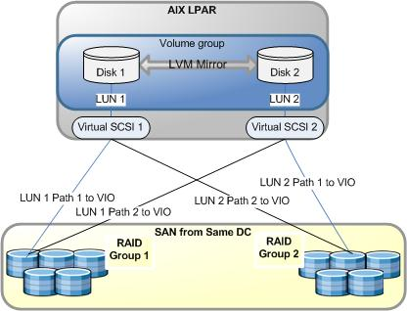

Data Availability in Host-Based Mirroring
Failure Scenario | Data Availability Impact
HBA Failure | The Data will still be accessible from the other disk through other HBA.
Disk Failure | As two copies of data are kept in two different disks, the data will be accessible from other disk.
VIO Server Failure | As paths are presented from each VIO LPAR, the path for the disk can still be accessed if a VIO LPAR fails.

Network Configuration for LPAR
All LPARs will have three VLAN’s configured, one is Service Network and others are Admin and Backup Network. A brief description of these VLAN’s and other VLANs used for AIX are provided below

Service Network

Admin Network

Backup Network

Design Statement
Design Statement | Rationale
LPARs will have three networks configured | To segregate the administration traffic and data traffic. This will avoid any interruption to the data traffic as well strengthens the security.

VIO LPAR Configuration
This section describes in detail about the network and storage virtualisation achieved by VIO LPAR.
VIO (Virtual Input Output) LPAR which runs on AIX OS provides network and storage virtualisation for all other AIX LPARs. Hypervisor, which is a P6 firmware, acts as a bridge between the VIO LPARs and the AIX LPARs.

- Shared Ethernet Adapters (SEAs) will be configured using “etherchanneled” adapter and a virtual adapter for all networks.
- Each SEA will be configured with a virtual adapter named “Control Channel” adapter, for the heartbeat between VIO LPARs

Network Virtualisation on VIO

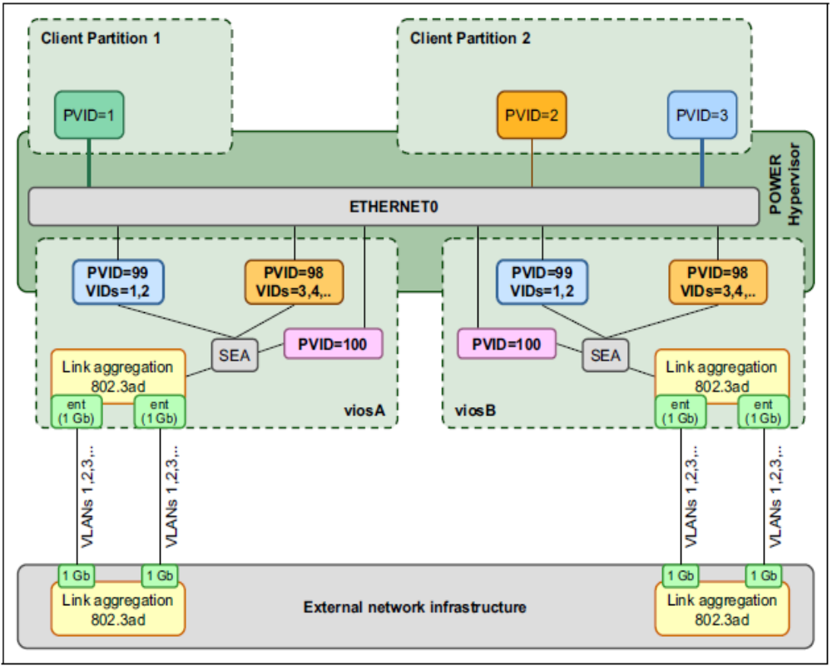

Link aggregation (etherchannel) Configuration on VIO

High availability configuration on VIO

Vlan Tagging

Storage Virtualisation on VIO
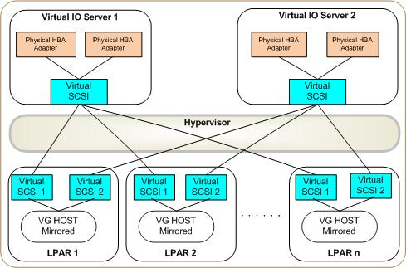

The following are the features of storage VIOs
- Data disks for virtual LPARs will be presented through dedicated HBAs on the VIO LPAR.
- Each VIO LPAR will be assigned with a SAS controller for local disks.
- Boot disks will be provided from storage VIOs to all LPARs.
- Both Virtual SCSIs on LPAR will be in active/active configuration.

High availability of virtual SCSI using Storage VIO
- Each VIO server will be configured to create virtual SCSI termed as “vscsi” for each LPAR.
- This “vscsi” from each VIO LPAR will be tagged with a unique “vhost” number for each LPAR. This number will be same on both the VIO servers for each LPAR.
- High availability will be achieved even in the case of one VIO fails or physical HBA fails, the disks are still accessible for the “vscsi” or HBA from the other VIO.

HMC Configuration

HMC is used to perform logical partitioning functions, service functions, and various system management functions using either the web browser based user interface or the command line interface (CLI).HMC is a separate, rack mountable server that runs specialised software for communication with the pSeries server’s service processor and hypervisor. It is a critical part of allocating resources and providing resource management to the running systems.

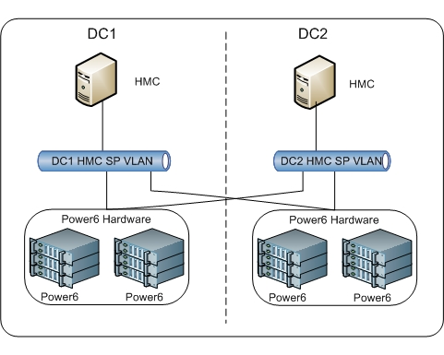
The following are the key consideration for HMC configuration:
- HMC’s will be configured for accessing frames across the data centre.
- For Managing DMZ frame, a dedicated HMC on each data centre will be configured on the DMZ layer.
- RMC, a feature in HMC will be used to perform dynamic operations such as CPU addition, memory addition to an LPAR, will be enabled on all networks for the HMC.

Network configuration for HMC
HMCs will have three physical network connections:
- HMC-SP network: Each HMC will have non-routed VLAN which connects it to the HMC ports of frames. The HMC acts as a DHCP server on this network.
- HMC Service network: This network will be configured as secondary access for remote HMC operations. This network will be same as Service network configured for LPARs.
- HMC Admin network: This network will be configured as primary access for remote HMC operations. This network will be same as the Admin/backup network configured for LPARs.

HMC Access Configuration
- HMCs will be accessed through a web browser (over HTTPS) and through command line interface (over SSH) by root user of only AIX-LDAP.
- Only one administrator user named as “hscroot” will be created for HMC.

Design Statement
Design Statement | Rationale
Two HMCs for each P6 frame | This is to provide high availability for accessing P6 frame, if any one fails.
Dedicated HMC for DMZ | As a best practice for managing P6 frame in DMZ layer, a dedicated HMC will be configured in DMZ layer.

NIM Server Configuration
This section describes in detail about the NIM configuration for Midrange Infrastructure. NIM is used for centralised management for all Installation, OS backup activities on all AIX LPARs.
- 2 NIM servers will be built across each data centre and one will be configured as Primary NIM server termed as “Primary NIM Master” and other will be configured as backup NIM Server termed as “Alternate NIM Master”.
- HANIM will be configured for high availability and the NIM configuration will be synchronised between primary and alternate NIM master on daily basis.
- All LPARs (AIX and VIO) will be configured as NIM clients to Primary NIM Master.
- “nimsh” will be configured for communication of NIM Master to its clients.
- NIM will be configured to communicate to its clients on Admin Network only. Service Network will be configured on a virtual adapter and admin network will be configured on an etherchanneled adapter.
- Each NIM will be created with two application volume groups apart from rootvg named as “nimvg” and “backupvg”.
- LPAR and VIO provisioning for installation will be done from NIM master using ‘master imagesfollowed by automated configuration (scripts) for those things that cannot be contained within an image (for example configuring IP addresses, mirroring rootvg and so on).
- Application install images will be held on the NIM Master. The NIM Master will be mounted using NFS onto LPARs when installs are needed. This avoids the need to hold all of the code locally.
- Local Disks will be used for configuring nimvg and backupvg,
- ‘bootps’ ,’nimsh’ and ‘tftp’ ports will be opened on the DMZ firewall for accessing the DMZ servers over the Admin LAN
- The following filesystems will be created for “nimvg” and “backupvg”:

Standard Filesystems on nimvg
Filesystem | Purpose
/export/nim/software | For Software and OS binary storage
/export/nim/lpp_source | For LPP Source resource
/export/nim/images | For Storage of Installation Images
/export/nim/scripts | For Storing Customisation Scripts
/export/nim/rpm | For Storing RPM Packages
/export/nim/spot | For Storing NIM SPOT resources

Standard Filesystems on backupvg
Filesystem | Purpose
/export/nim/LPAR_mksysb | For Storing LPAR MKSYSB
/export/nim/VIO_backup | For Storing VIO Backup
/export/nim/hmc_backup | For Storing HMC Critical data

OS, VIO Backup and Recovery Configuration for NIM
- All LPARs, VIOs and HMC on a frame will be backed up to a NIM Master in the respective Data Centre.
- Each NIM server needs to be provided with 10GB of local SAS disk for each LPAR on the frame for the mksysb (OS backup) and will be added to “backupvg” (including the VIO servers).
- mksysb for DMZ servers will be taken locally on the server and then transferred to NIM Server.
- Backup images from the NIM will be backed up by backup solution and retained according to standards and application backup requirements.
- Master NIMs also back up to themselves; and the images will be written to back up solution.
- If a NIM needs recovery from mksysb then it will be made a client of one or other NIM master while that recovery takes place. The image will be brought onto the NIM master from backup solution.
- If an LPAR or VIO needs recovery then it will be done using the frame NIM. If the frame NIM is unavailable then it will be made a client of one or other NIM master – and the image needed will be brought from backup solution.
- If a master NIM needs recovery then it will be made as a client of the other master NIM – and the image brought from backup solution.
- Backups and recoveries to/from a frame NIM will be done using the backup network.

AIX-LDAP Server Configuration

This section describes about the AIX-LDAP configuration which is used for authorisation and authentication of all AIX LPARs. AIX-LDAP server will be implemented to authenticate and authorise all users who needs command line access to LPARs.
The following diagram shows the AIX-LDAP setup:
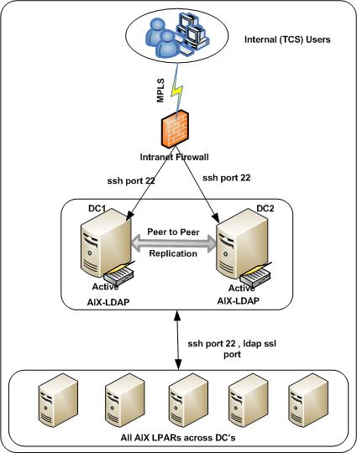
The following are key considerations for LDAP configuration
- AIX-LDAP will be built on each data centre and will be configured active/active configuration and LDAP data will be replicated to each other on a daily basis.
- Service network will be configured on etherchanneled adapter and admin network will be configured on virtual adapter.
- Users will initiate SSH session from desktop to IP of the AIX-LDAP LPAR and the user will be presented with the list of servers based on the user’s profile.
- Once user selects the server name SSH request will be initiated from AIX-LDAP server to LDAP Client (AIX servers will have LDAP client).
- SSH will carry the authentication key from AIX-LDAP server to LDAP client and the same will be compared and authenticated. Then, the user will be prompted with Multifactor Authentication to login into the server.
- All the requests to access home directory of the user and permissions will be configured via LDAP SSL port .
- All midrange LPARs will be registered under the netgroup “midrange-unix-servers” and only the midrange administration team should be registered to this netgroup.
- Logical grouping of users will be done with respect to the application they work on and access will be provided only to LPARs hosting their application.
- All users, groups and services will be defined only on AIX-LDAP server.No local users, groups or service ports will be configured locally.
- Sudo roles will be defined only on AIX-LDAP server.
- As part of AIX LDAP configuration, password will be stored in encrypted format.
- LDAP user ID will be disabled as part of removal of access rights and user will not be able to access any system without LDAP ID.
- SSH and LDAP SSL ports will be opened on the DMZ firewall for DMZ LPARs.

The following table provides the users roles which will be defined in LDAP:
User Roles
Role | Definition
Admin role | AIX administrators  Login access to all LPARs  Switch user to root
User role | All non-AIX administrators  Login access only to their application LPARs  Switch user access to their application related service accounts
Service role | Service Accounts for installation and administration of applications

AIX-LDAP Standard Security Settings
The following table provides AIX-LDAP standard security setting which will be followed.
AIX-LDAP Standard Security Settings
Policy | Value
Max time of Password validity | 30 days
Number of previous passwords which cannot be reused | 12 months
Invalid Login attempts | 3 times (User will not be able to login after 3 invalid login attempts unless the account login count is reset by the administrator).
Minimum Length of the Password | 8 characters
Password Strength | Min 1 Alpha-numeric character  Max 2 characters can be repeated  Min 2 characters not repeated in the previous password
Service accounts direct login | Disabled
Switch user to root | Only to Admin role

Clustering configuration using HACMP

Diagram

Failover Scenarios
Failure scenario | Data/Service availability impact
Any one server failure | The existing volume group or service will failover over to another LPAR configured within the HACMP cluster.
Total Disk Failure in one DC | HACMP along with configured storage scripts will failover the resources.
Network Adapter Failure | The HACMP will automatically fail over to other node.

NTP Service
All AIX LPARs will be configured to synchronise time from the NTP Server configured at each DC

Patch and Update Management

Update/Patch Management on AIX is not done on a regular basis. It will only be done when IBM recommends update/patch to fix a critical issue
OS/Application will be upgraded to the Latest level before the end of the support cycle
The following Tasks will be performed during the Patch cycle for the OS/Application/DB.
- An assessment and review of available patches/updates.
- A review of applicability.
- Deployment review to determine which patches will be deployed.
- Documentation of Test Results for auditing purpose.
- Implementation

Design Statement
Design Statement | Rationale
Applying of Patch | Based on the IBM notification, patches/updates will be installed and configured on Dev/SIT/UAT/Pre-Prod and Production in sequential order. This will provide sufficient period to avoid any impact to the Production environment.

Midrange Scalability
- The proposed Midrange infrastructure solution will be scalable by adding additional Power servers.
- LPARs are scalable by adding CPUs and memory dynamically .
- Servers configured for HACMP clustering are scalable up to 32 nodes.

Monitoring
All LPARs, VIOs and VMs will be monitored for the following

Components | Considerations
File Space | Monitors all file systems for used space and generate Warning alerts (default 70percent full) or Critical alerts (default 85percent). Alerting percentages are configurable.  Alerts for application filesystems will be sent to appropriate application support teams via Tivoli Service Request Manager .
Physical Disk | Monitors disk visibility and alerts when disks or SAN paths to disk are lost.  Monitors status of disk volume configuration and alerts on incorrect settings and loss of mirroring.
Error Logs | Monitors hardware system error log.  Windows Event Logs will be available in “percentSystemRootpercent\System32\Config”  AIX logs will be available in “wtmp”, “.sh_history”, “/var/adm/messages”.
Processes | Monitors for processes (daemons) running on the server – configurable and typically processes outside of cluster control. Alerts if the processes are missing.
Crash Files | Monitors for core files (process crash files) and alerts if found.

- LPARs will run UNIX, AIX Premium and Universal agents plus a custom agent delivering the customised standard alerting for applications, database and network device monitoring, more details on the mechanism will be available in the Monitoring design document.
- Frame NIMs will additionally run customised agents and HMC agents.
- VIO servers will run VIO Agent for monitoring

Monitoring Threshold Limits
Parameter | Warning Alert Threshold | Critical Alert Threshold
CPU | 75% | 90%
Memory | 70% | 90%
File System Usage | 75% | 90%
Failed Logins | 4 | 8
Unknown user ids | NA | 1
All warning alerts will be sent to IS support team and the concerned individual where applicable. All critical alerts will be sent to IS support team, relevant application teams, individuals and immediate supervisors and the management team, based on the criticality

Operations Team Activities
For all LPARs:
  - Archive the failedlogin log after alerting the support team and relevant stakeholders.
  - Archive the sudo log on a daily basis.
  - Alert daily if anyone, not in an authorised list, is using “su” to root. Archive the sulog.
  - Archive the wtmp(login and logout) file to archive on a daily basis.
  - Alert, if, any changes have been made to /etc/passwd or /etc/group.

